

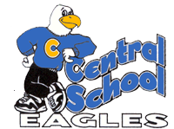

Baldwin’s Blast

February 2017

**Superintendent’s Corner**

One of the goals of the district’s strategic plan, which was adopted by the Warren Township Board of Education in 2013, is to reinvigorate the Warren Township Education Foundation (WTEF). This group is made up of dedicated members of the Warren Township community with the goal of raising funds to support the schools in ways that go beyond the district’s budget and the wonderful work of each school’s PTO.

The WTEF will be holding an information session on Wednesday, February 8, 2017 at 7:00pm in the Warren Middle School library. The focus of the meeting will be to share information about the organization’s plans for the remainder of the school year and the future and how members of the community can get involved in several different ways such as planning and organizing fundraisers, making connections with the local business community, and supporting a mission aligned with the Whole Child vision of the school district. All members of the community are invited to come learn about the WTEF and opportunities to contribute to this important group.

With the right mix of enthusiastic individuals, this group can make a huge impact on the educational experiences of all children in the community. I hope you will consider finding out more at this information session.

Matthew A. Mingle, Ed.D.

**Principal’s Corner**

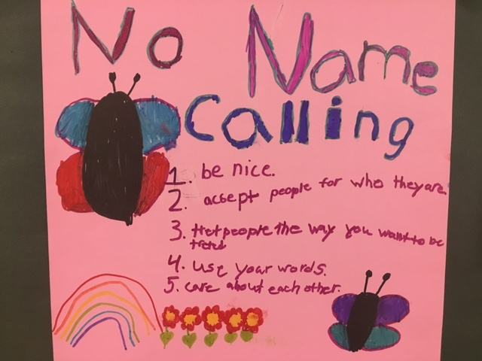

Recently, Central School celebrated its first ever No Name Calling Week.  Miss Katchen, our school guidance counselor, collaborated with students to make a video launching the week and our No Name Calling project.  Students ran with the idea and submitted posters, models, dioramas and drawings depicting what can happen when we call each other names, and how wonderful it feels to have peers stand up for each other in times of need.  In January we also participated in our first school wide character education lesson.  Everyone who spends their days at Central stopped what they were doing at the same time and spent a half hour engaged in lessons and activities on the month’s topic, listening.  Kindergarteners learned about listening position and listening power, while older students dove deeper into what respectful listening looks and sounds like. As our students soar academically this year, they also grow socially and emotionally, engaged in thinking about how to help build each other up.

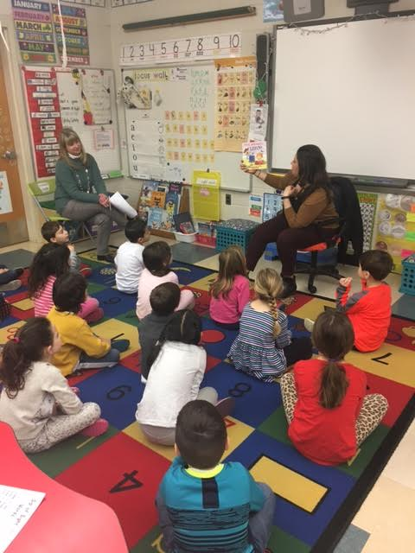

The home school partnership is one of the most powerful assets we have in our Central School community.  Ask your child(ren) what they’ve learned in school during No Name Calling Week and our school wide character education lessons.  Having similar discussions both in school and at home serves to strengthen the message and learning that occurs. As always, I value your partnership and support for everything Central School.

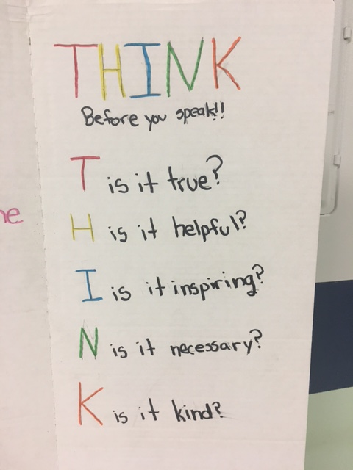

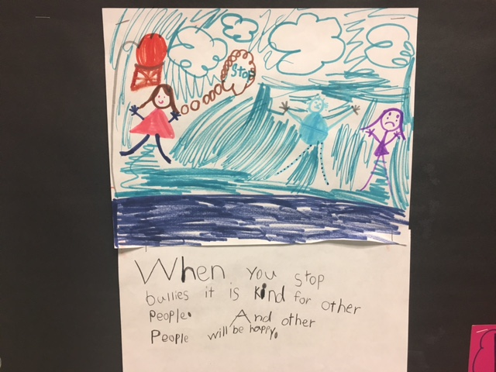

**Grade 4**

This fourth grade year has been flying by! We can't believe that it's February already. The students have been working hard to learn all kinds of concepts in writing, reading, math, science and social studies.

In writing, students are learning strategies for writing an opinion essay. They are studying how to hook their readers, write powerful closings, and provide evidence to support their thesis statements and reasons.

Later in the month the students will be starting their next unit in science: Land and Water. The students love to explore the many facets and elements of land and water. In this unit, as with all fourth grade science units, much of the students' learning is derived through exploration and experimental learning with guidance and structure. They enjoy having an opportunity to gain knowledge via a hands-on approach, while working in collaborative groups.

The students are very excited to be participating in a research project with our librarian Mrs. La Neve. Each student has chosen a famous person to study. Students will read a biography and gather notes from both the book and other on-line resources. Then students will create a Google Slide presentation to share with their classmates.

In reading we are delving into a non-fiction unit of study. Students are reading a variety of non-fiction texts and recording their questions, reactions and ideas.They are also learning how to find evidence in two texts to compare and contrast them.

In Social Studies we are studying the first people of New Jersey and different regions of the United States. Students will be working collaboratively to teach each other about the different Native American Tribes.

Lastly, in math students will be working on fraction equivalence and comparisons. We will be starting to add and subtract fractions. Then, we will begin to multiply fractions by whole numbers, and demonstrate the relationship between fractions and decimals.

Notes from the Nurse - Sharon Carroll, RN, MSN, CSN

February is Dental Health Month. Please reinforce the importance of good oral hygiene to your children.

* The teeth and the tongue should be brushed at least twice daily (morning and evening).
* Floss daily!
* Change your toothbrush every 3 months and after illness.
* The ADA recommends check-ups every 6 months for school age children.
* Keep hands away from your mouth and nose to avoid germs.
* Nutrition also plays an important role in dental hygiene.
* Limit foods and beverages with a
* high sugar content
* Include more fruits and vegetables in your diet
* Drink plenty of water

Keep Smiling! MCj04280730000[1]

Reminders: 5th graders need (2) vaccines prior to 6th grade. Please bring documentation to the health office.

